**2.REACTJS – HOL**

1. Explain React Components

A React Component is a reusable, independent block of code that returns a piece of UI. Components allow modular, maintainable, and reusable code in React applications.

2. Differences Between React Components and JavaScript Functions

| Feature | JavaScript Function | React Component |
| --- | --- | --- |
| Purpose | General logic or calculation | Renders UI |
| Return Value | Any data (number, string, etc.) | JSX (UI element) |
| Reusability | Yes | Yes |
| Syntax (Functional) | function myFunc() {} | function MyComponent() { return <h1> }</h1> } |
| Syntax (Class) | Not applicable | class MyComponent extends React.Component {} |

3. Types of Components

* Functional Component – Uses plain functions to return JSX
* Class Component – Uses ES6 class syntax, allows use of lifecycle methods and state

4. Explain Class Component

A Class Component is created using class syntax and extends React.Component. It must have a render() method that returns JSX.

class MyComponent extends React.Component {

render() {

return <h1>Hello from Class Component</h1>;

}

}

5. Explain Function Component

A Function Component is a plain JavaScript function that returns JSX.

function MyComponent() {

return <h1>Hello from Function Component</h1>;

}

6. Define Component Constructor

In Class Components, the constructor() is used to initialize state and bind methods.

constructor(props) {

super(props);

this.state = { name: "Student" };

}

7. Define render() Function

The render() method is mandatory in class components. It returns JSX that is rendered on the UI.

Prerequisites:

* Node.js
* NPM
* Visual Studio Code

**STEPS :**

**Step 1: Create React App**

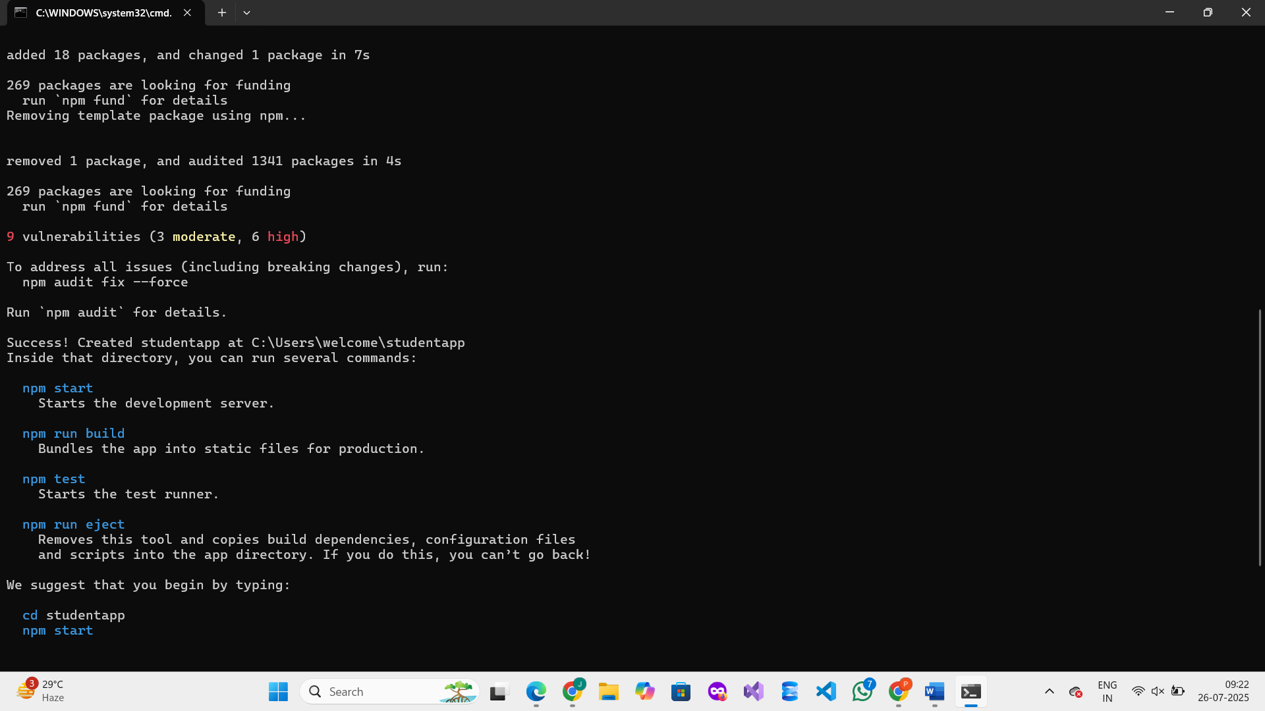

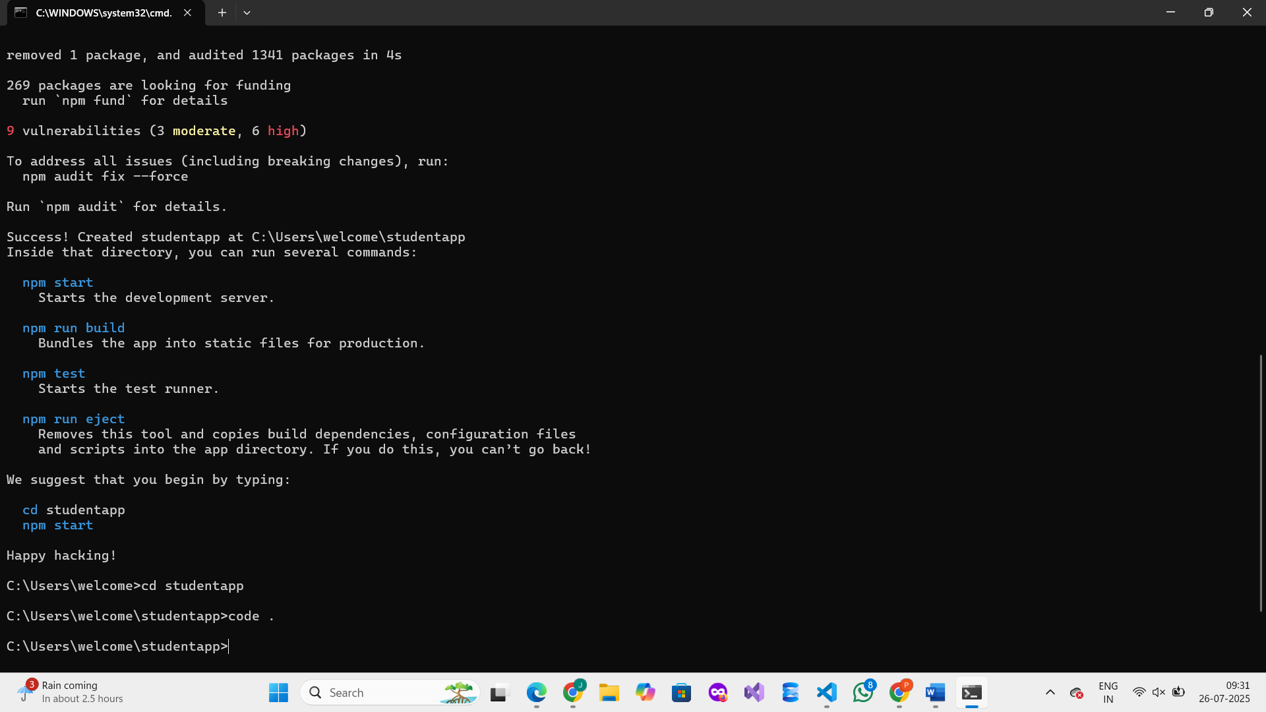

**Step 2: Create Folder and Component Files**

1. Inside src, create a new folder named:  
   Components   
   Inside Components, create three files:

Home.js  
About.js  
Contact.js

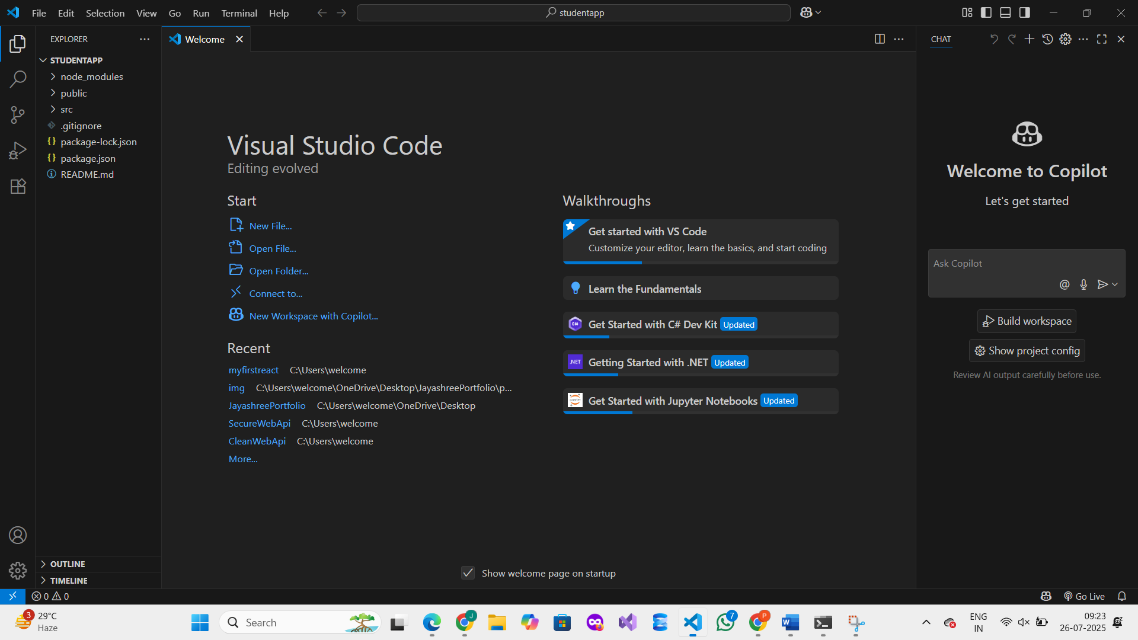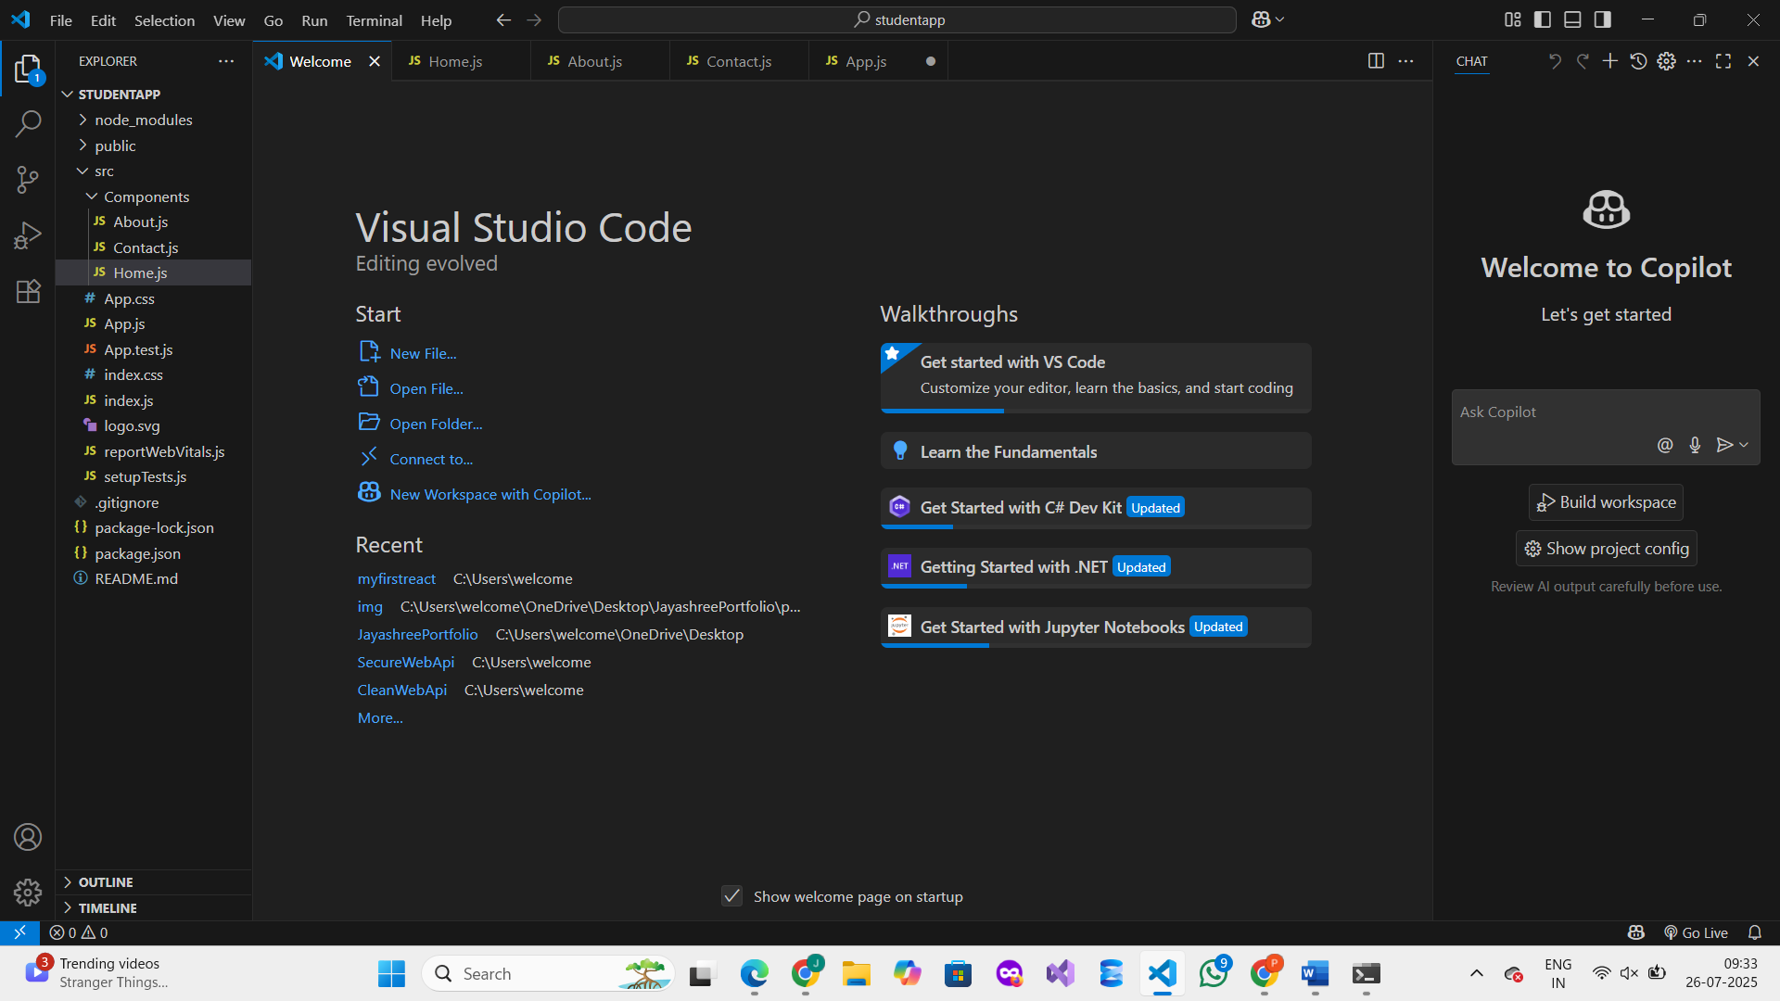

**Step 3: Add Code for Each Component**

**Home.js**

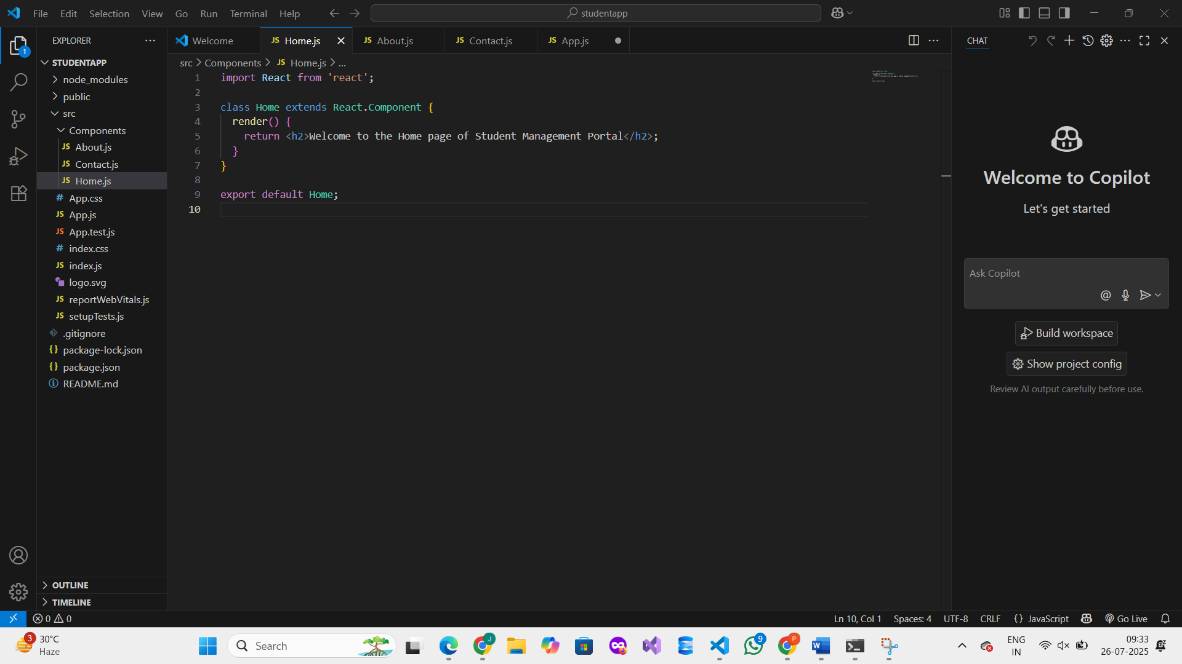

**About.js**  
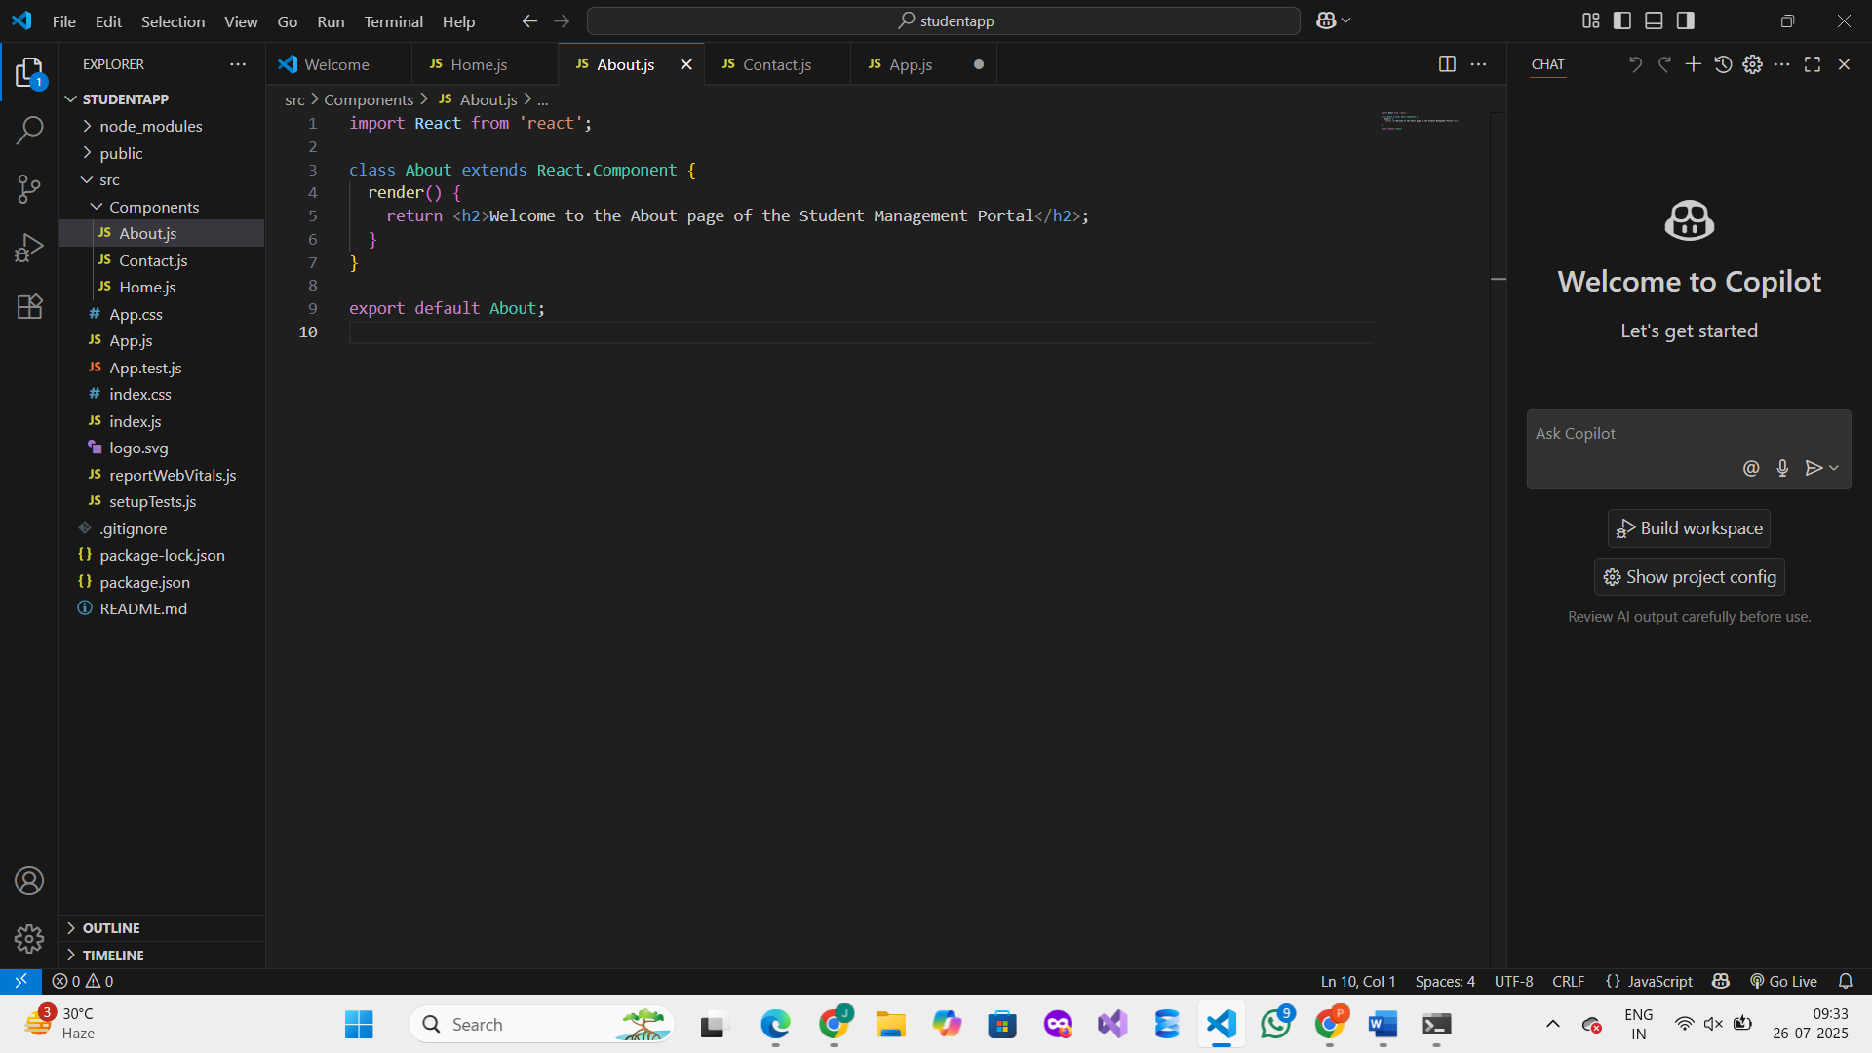

**Contact.js**

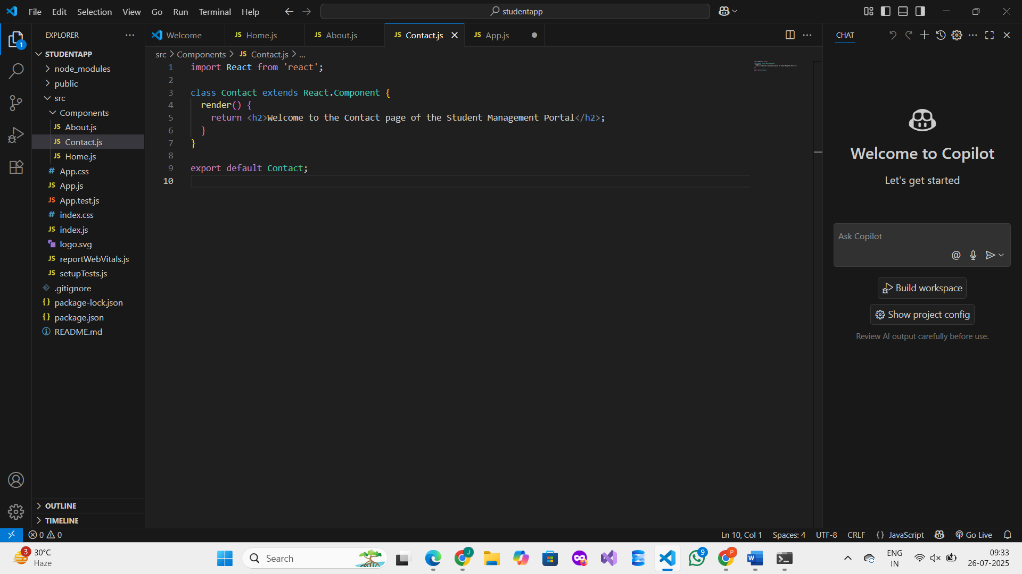

**Step 4: Edit App.js to Call All Components**

